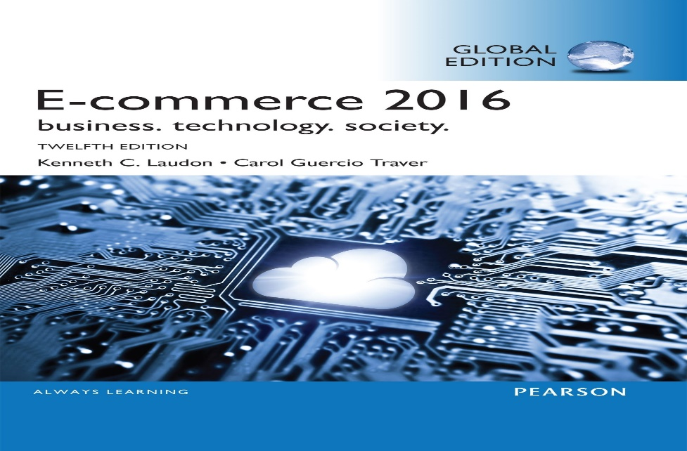
E-COMMERCE 2016 BUSINESS, TECHNOLOGY, SOCIETY

Authors Kenneth C. Laudon. Carol Guercio Traver

Article review project

By

Introduction
Technology has a lot of influence on the business. Computer technology has been used to improve the systems of organizations. One of the activities that have been improved by technology being introduced is the accounting department. Financial professionals are obliged to prepare and analyze the financial records for different organizations. The task that is carried out includes computing the financial data, recording the data. The computers are also used in computing and posting the analyzed data. Accounting is critical in all aspects of the different organizations. In auditing, different experts are hired, such as payroll specialists and financial planners. Technology in business has also been used in business administration; the professionals in an institution will utilize technology to analyze business situations and make long-term plans for the company's success. They make projections on the future potential of the business. With technology, the ability to coordinate staff becomes easier.
A business with good technology will provide good computer networking, which is local area networks and intranets. The network specialist is important because they have a positive influence by making business plans that will help achieve goals set by the organization. Through networks, the business can reach more suppliers and customers who will aid in moving the company to the next level of success. Technology is important because it provides technical assistance and support that will be based on information technology. Organizations with computer networks will have efficiency in supporting contract agreements and offer services to the firm customers. The businesses can practice skilled marketing based on social media that will aid in promoting the brand that will create more profitability for the firm. Through business technology, the organizations have more entrepreneurial ability to invest in new brands that have turned profitable because they have a large market share.

Summary of article
Through the integration of computers in business technology has resulted in the emergence of E-commerce; through E-commerce, new digitals markets where the consumers can easily access the prices. Technology has made it easy for companies to develop global market shares; through technology, trading has become very efficient where consumers can access goods and services at the right time. E-commerce has a direct relationship with the relevant stakeholders, including customers, suppliers, and competitors in the markets and the partners in the markets. Digital marketing is another advantage of the technology; this will fetch more capital to the firm due to product branding. Technology influences product design, financial benefits of the firm from sales and logistics. Technology has a positive impact on reducing the cost associated with logistics in supplying goods and services. Through advanced technology, a firm can develop production efficiency that will result in high output levels and increased returns. Marketing has been enhanced through adequate advertising of the products that have become positive in the revenue realized. Internet technology has a direct impact on E-commerce.
Through advancement in technology, E-commerce has developed in the following perspectives of developing secure methods of making payments for products and services offered by a company. Development of long-term strategies on the marketing of the products, financial decisions of the firms are based on the big data analysis that gives mandate to the professionals to decide on the best methods to undertake that will be profitable to the firm. Retail business has enormously developed that has increased the supply of goods to the consumers. Rapid growth in the computer platform has resulted in the emergence of new software tools and applications that are being used for financial computations and digital marketing. The article summarizes the advantages of technology to the business where global commerce through the internet has led to an increase in revenues that the firms are earning. The technology has come up to outshine traditional advertising methods that included post and television and developed to a more digitalized platform. Social marketing has grown faster in recent years due to display advertising of the products on sale.
The business can develop models that are being used for analysis in the markets where the top management utilizes the models to make desired levels of achievement following the organization's set goals. The emergence of new payment methods has led to transaction efficiency that has contributed to an increase in cash flows in the business entities. Companies have invested in cloud services that have increased the computing infrastructure's efficiency necessary to provide critical information on digital platforms. More software apps have grown rapidly, leading to efficiency in different departments in the companies that include financial analysis and marketing of the brands available. The companies have benefited due to a decline in prices of developing the software; this has resulted in a shift of the businesses from the traditional settings to the current digital E-commerce. The companies can develop standards of measuring market efficiency, which will depend on analysis done based on the customers' social networks who are receiving service from the companies. Through advanced technology, the companies have developed strategies to develop strategies to know their target markets and segmentation to match the demand and supply of goods. Digital companies have used dynamic pricing strategies to make relevant prices to their consumers.

Main points of the article with reasons.
Point #1: technology has played a major role in promoting production efficiency by increasing the output a company produces; thus, there is more income revenue.
Reason#1: This is because, in the digital era, more remarkable changed have been cited due to advancements in technology. There is more employee engagement in their tasks that will subsequently lead to an increase in output. The firm's communication flows easily; this will promote the generation of new ideas that will be used as resources to enhance the product brand's image. With effective technology collaboration, it will be easier for the employees to achieve overall organizational goals.
Point #2: digital technology has increased marketing and advertisement of the products, resulting in more customer satisfaction with the available products.
Reason#2: companies that have developed digital marketing strategies have won a big share in their markets by creating a good image of their products in the markets; thus, the product brand will be purchased more.
Point #3: a stable relationship is created between customers, suppliers, and the company by advanced technology.
Reason#3: With a good and stable relationship between customers and the company, customer loyalty will be prevalent, making the company profitable; the suppliers will ensure a steady supply of inputs that will result in a continuous production process.
Point #4: product advertising has developed intensively that has increased sales.
Reason#4: advertising is crucial to the company products that will make it easy for the consumers to identify the product brand uniqueness. This will favor the company as many customers' preferences will be based on the most familiar products; this can only be achieved by advertising them.
Point #5: unique product branding resulted from technological knowledge of adding value to the available products.
Reason#5: product branding is important in creating a good image of a company that will result in more profits due to the product's unique characteristics in the markets. A branded product will attract many customers to purchasing it.
Point #6: comprehensive business plans have been developed through the technology considering the risk associated with the business and the effective strategies of absorbing the risk.
Reason#6: a company with a good business plan will survive in difficult economic times; thus, they will have a longer life cycle to benefit the firm's investors.
Conclusion
The article has given the advantages of integrating a business with the modern technology that has resulted in the products' production efficiency and marketing. We can conclude that digital marketing of products will benefit the firms. To develop a competitive edge, firms must work to improve their technology level; by doing this, they will enjoy large market values globally and at the domestic levels. A decrease in transactional cost in some aspects to the firms is beneficial because this will reduce the amount of money invested while maximizing the output level, which is all business firms' goal. Despite the advantages of some of the prevalent limitations, there is disruption of company privacy due to accessibility for other stakeholders involved in making profits. The article is well written with a credible flow of information that clarifies points that necessitates authenticating technology's importance to the business entities.
Information from the article conforms to the evident practices on how the company can elevate its status due to implementing new technologies in its production process. Lessons learned from the article include the importance of firms developing their technologies to cope with the market dynamics to avoid failure in making subsequent profits resulting from obsolesce of the available technology. Establishing a good relationship with stakeholders through the digital platform will positively impact the returns to a company. Digital platforms in the marketing fields have led to a significant revolution in business. For an individual who is interested in starting a business, technology is a core factor for success. For a business person, incorporation of technology in the firm will have more advantages that will result from the income realized by product branding that will make it possible for farmers to buy more, through advertisement by use of technology the products will reach many of their consumers.

